1. Write a C program to input the length and width of a rectangle and find the area of the given rectangle.
2. #include <stdio.h>
3. int main()
4. {
5. int a, b;
6. printf("Enter the length and width of rectangle\n");
7. scanf("%d %d", &a, &b);
8. printf("area of rectangle is %d", a \* b);
9. return 0;
10. }

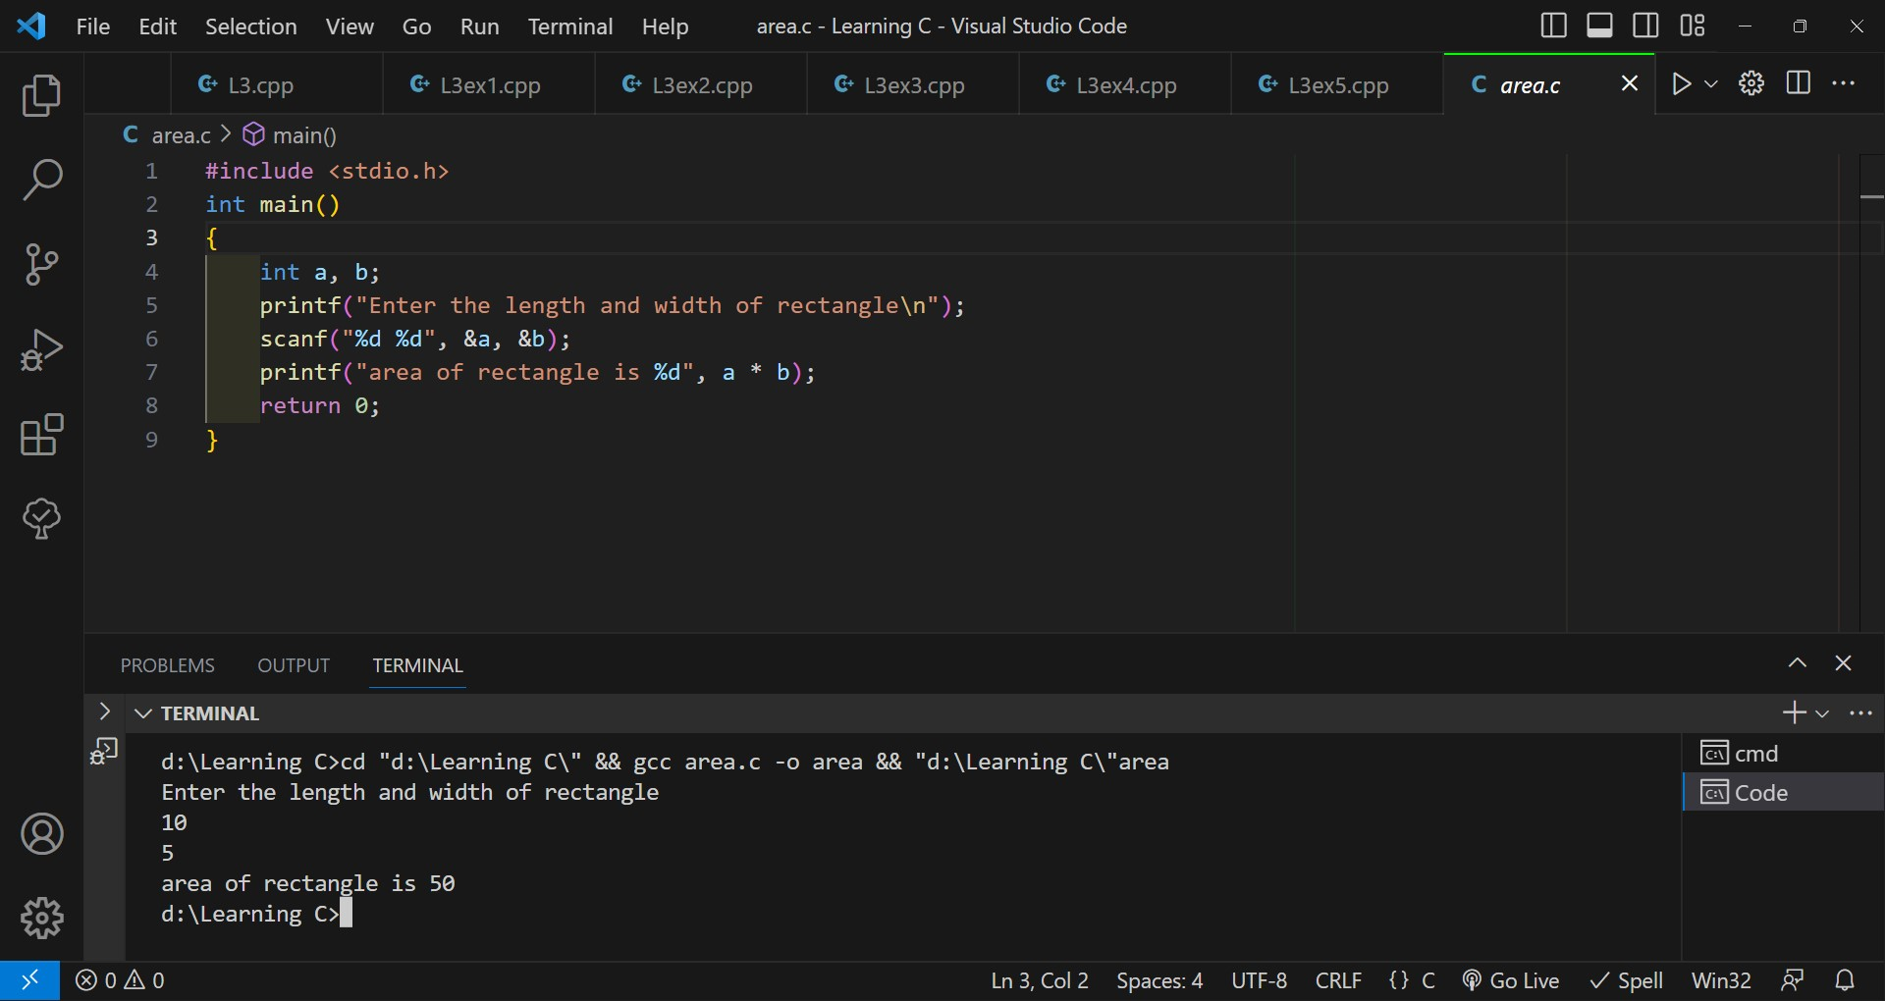

2- Write a C program to input two numbers and perform all arithmetic operations. How to perform all arithmetic operations between two numbers in C programming. C program to find sum, difference, product, quotient and modulus of two given numbers.

#include <stdio.h>

int main()

{

    int a, b;

    printf("Enter two numbers to find sum , product , difference , quotient and modulus\n");

    scanf("%d %d", &a, &b);

    printf("the sum of two numbers is %d\n", a + b);

    printf("the difference of two numbers is %d\n", a - b);

    printf("the product of two numbers is %d\n", a \* b);

    printf("the quotient of two numbers is %d\n", a / b);

    printf("the modulus of two numbers is %d\n", a % b);

    return 0;

}

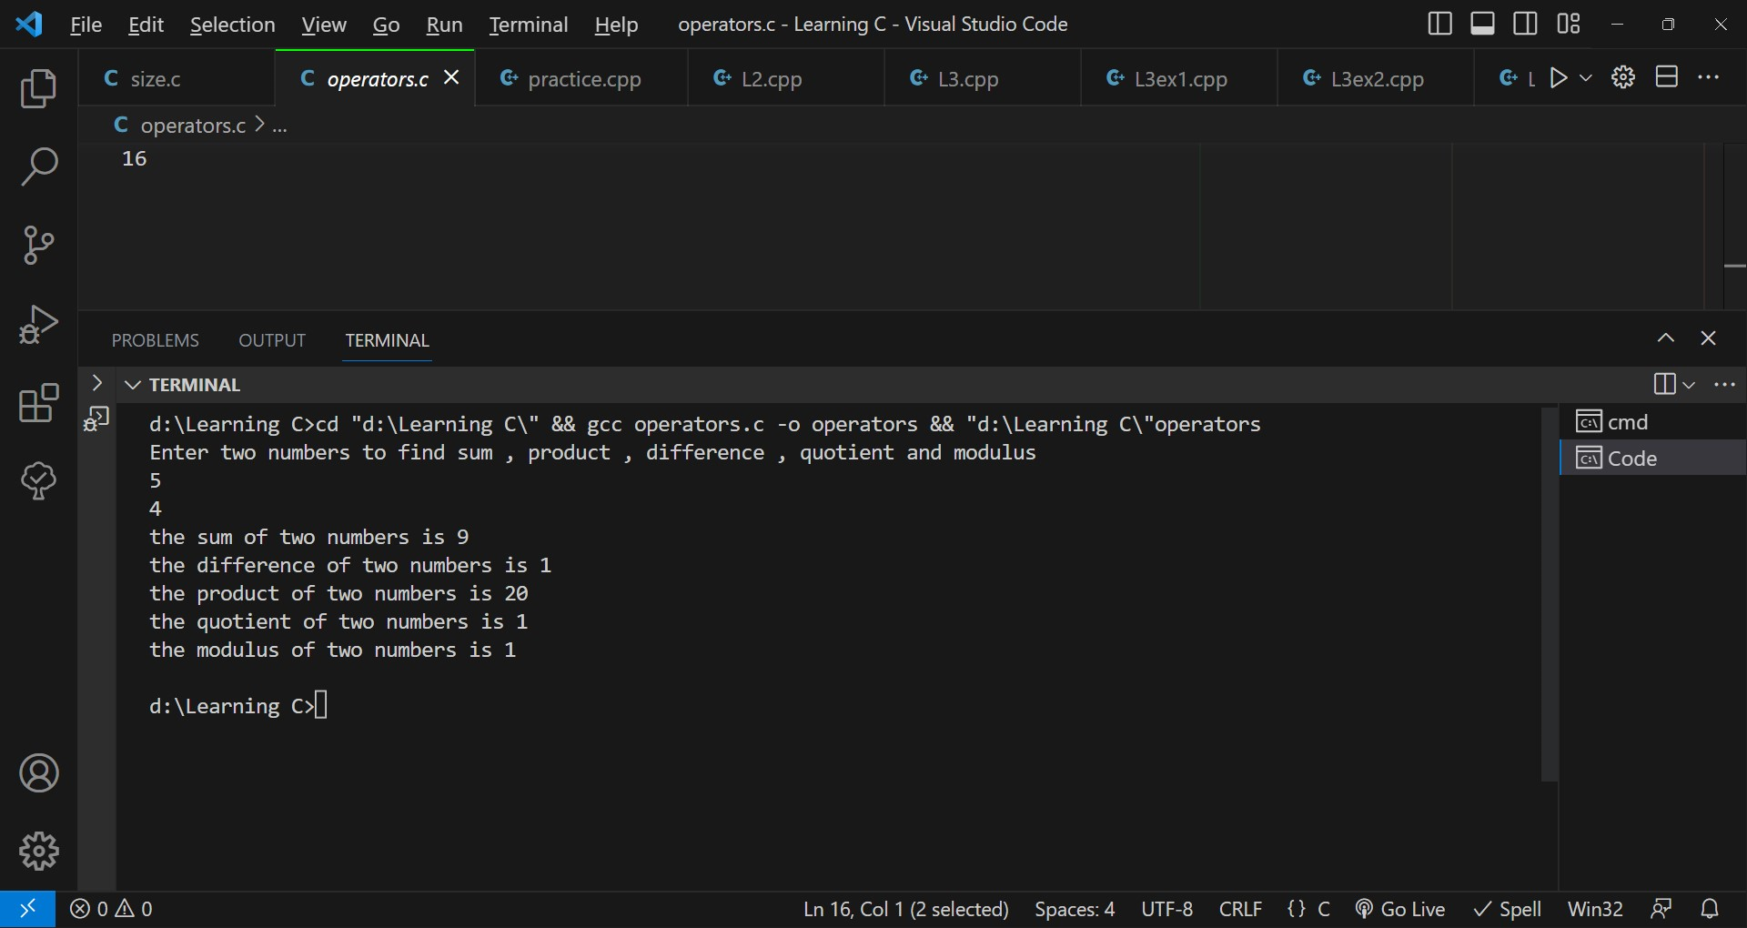

3- Write a C program to input principle, time and rate (P, T, R) from the user and find Simple Interest. Calculate simple interest in C programming.

#include <stdio.h>

int main()

{

    int P, R, T;

    printf("Enter your P,R,T:\n ");

    scanf("%d %d %d", &P, &R, &T);

    float S = P \* R \* T \* 0.01;

    printf("here is your simple interest %f", S);

    return 0;

}

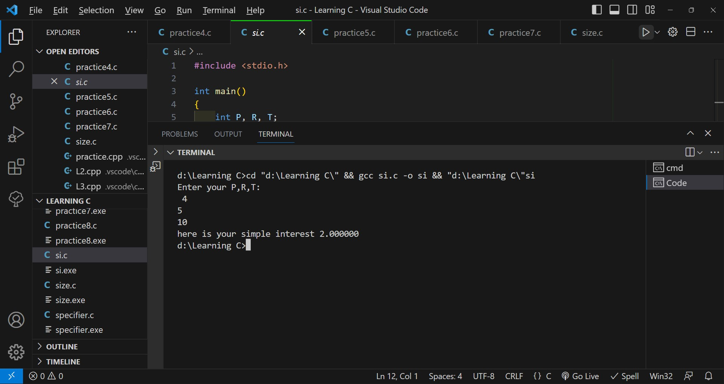

4- Write a C program to input temperature in Centigrade and convert to Fahrenheit.

#include <stdio.h>

int main()

{

    float c;

    printf("Enter temperature in celsius\n");

    scanf("%f", &c);

    float d = 1.8 \* c, f = d + 32;

    printf("%f", f);

    return 0;

}

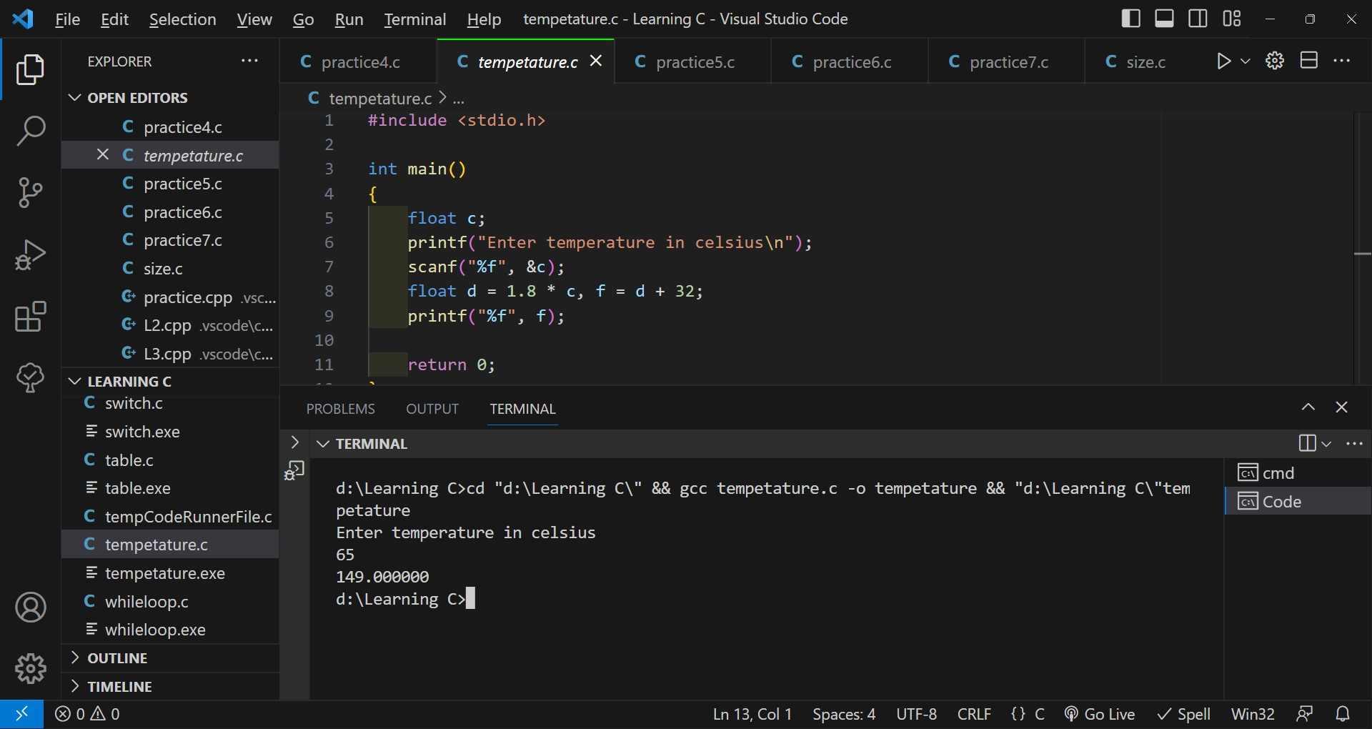

5- Write a C program to input the radius of a circle from the user and find diameter, circumference and area of the circle.

#include <stdio.h>

int main()

{

    float r, p = 3.14;

    printf("Enter radius of circle\n");

    scanf("%f", &r);

    printf("Diameter of circle is:%f\n", 2 \* r);

    printf("circumference of circle is:%f\n", 2 \* p \* r);

    printf("area of circle is:%f\n", p \* r \* r);

    return 0;

}

[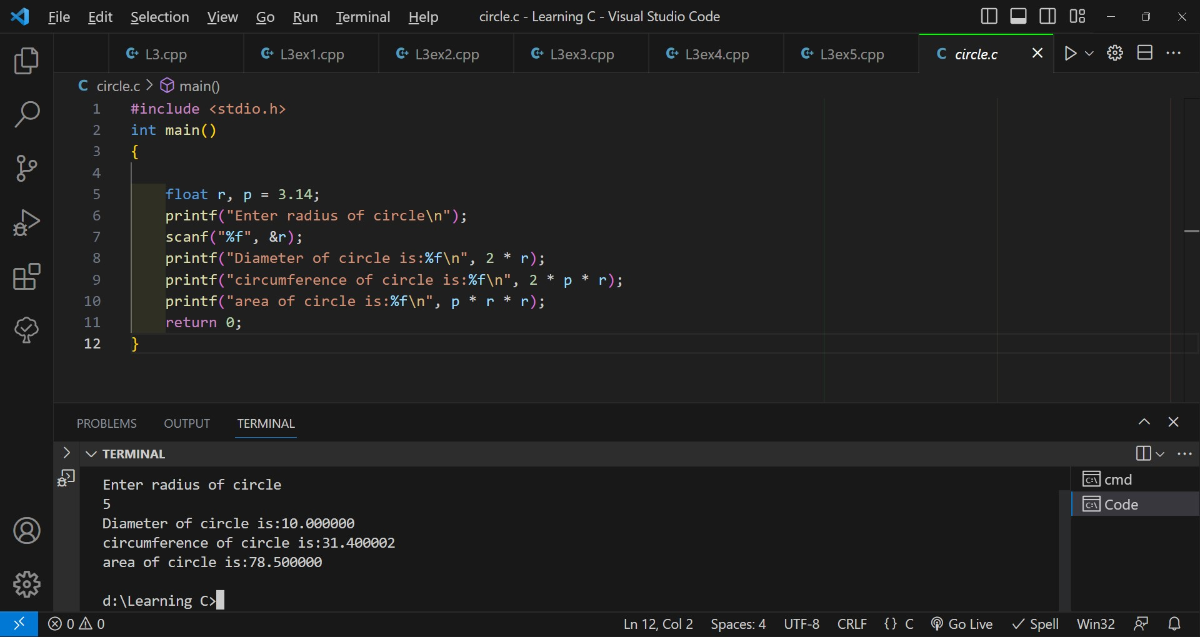](file:///C:\Users\HP\OneDrive\Desktop\Lab-1(23cs3048).pdf)

Previous assignment 